HUMEA Workshop – basic information

Date: 5th to 6th December 2016
Location: Czech Metrology Institute, Radiová 3, 102 00 Prague
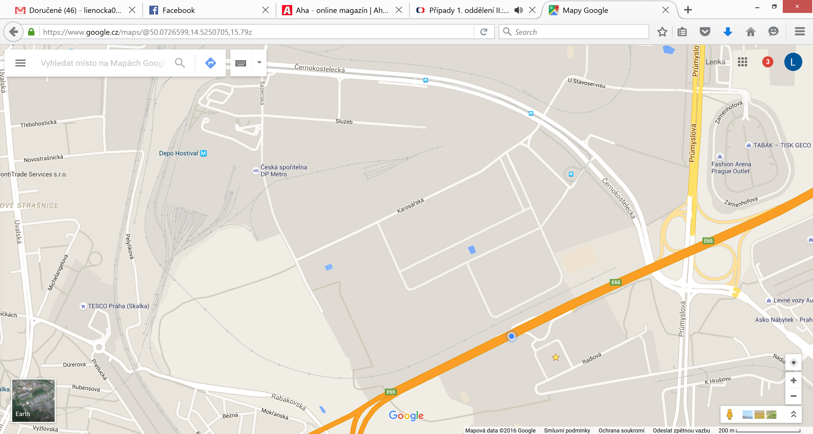

Closest public transportation station:
Bus: station Radiová, buses no. 181 (metro “red” line C station Opatov, metro “yellow” line B station Černý most), 182 (metro “yellow” line B station Vysočanská, metro “red” line C station Opatov), 183 (metro “yellow” line B station Vysočanská, metro “red” line C station Háje)
Metro: station Depo Hostivař (green “A” line), than take bus to the station Průmyslová (163, 208, 228, 229)
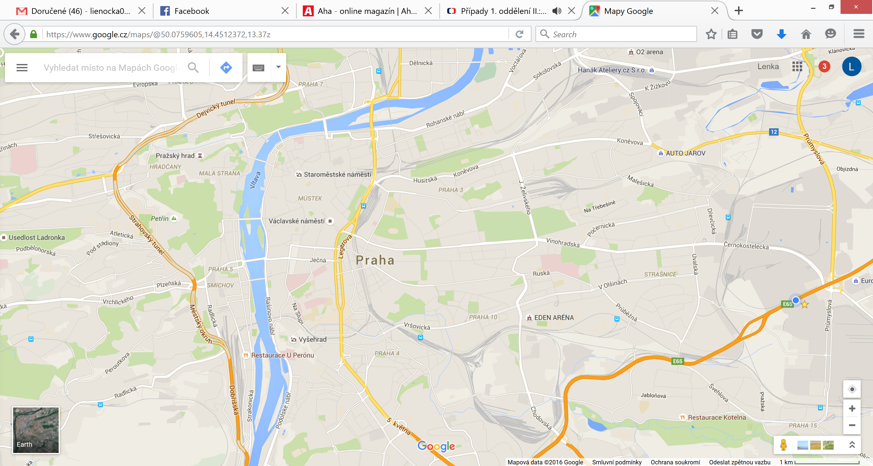
ČMI
City centre
Journey planner: http://jizdnirady.idnes.cz/pid/spojeni/
Registration fee: 50 €
Registration fee covers 2 lunches, 1 dinner and coffee brakes
All participants have to register through the website

